Nackademin -22 Internship

IBM

[IBM/Nackademin]

[PUMP DOCUMENTATION]

HARDWARE

HARDWARE 3

DPSD Lighted Pushbutton Switch: 3

Characteristics: 3

Wiring: 3

Relay Module For Arduino 1x: 3

Datasheet: 3

Characteristics: 3

WH148: 3

Characteristics: 4

Datasheet: 4

Characteristics: 5

Datasheet: 5

Alphacool Magnetic Valve – Chrome: 5

Datasheet: 6

Alphacool 17363 Eiszapfen Temperature Sensor G1/4 IG/IG Mit AG Adapter: 6

Datasheet: 6

7

Eiszyklon Aurora RGB: 7

Characteristics: 7

Alphacool Hardtube: 8

Characteristics: 8

Rasberry Pi 4: 8

Characteristics: 9

Datasheet: 9

Pin Assignments: 9

Arduino Uno: 10

Datasheet: 10

Aqua Computer D5 Pump Motor With PWM Input And Speed Signal: 11

Characteristics: 11

Alphacool NexXxoS XT45 Full Copper 120mm radiator: 12

Datasheet: 12

Alphacool Icicle Temperature Sensor Plug G1/4 Chrome: 13

Characteristics: 14

YF-S201 Hall-Effect Water Flow Sensor: 14

Features of Flow Sensor: 14

Datasheet: 15

Alphacool Eisbecher Helix 250mm Reservoir – Blue: 15

Characteristics: 15

O-Ring till Laing D5/Alphacool VPP655/Swiftech MCP655 16

Characteristics: 16

Servo 17

Documentation Water pump Ibm

# HARDWARE

## DPSD Lighted Pushbutton Switch:

Pushbutton

### Characteristics:

Type: ModMyToys (19mm) Illuminated Momentary Switch

Diameter: 19mm

Switching capacity: 3A / 250VAC

Form: Flathead  
LED type: ring lighting  
Colors: Red, Blue, Green, Orange  
Voltage: 12V  
Terminal: 6-Pin Terminal  
Temperature: -40 to 75 ° C

Total: 3 pushbuttons

#### Wiring:

## Relay Module For Arduino 1x:

Relay

### Datasheet:

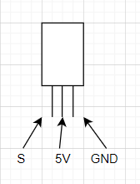

#### Characteristics:

Screw terminal with connection of both NO and NC.

LED indicates the status of each relay.

Max load/relay: 250V AC/10A, 30V DC/10A.

Total: 3 relays.

## WH148:

Potentiometer

### Characteristics:

Type: Linear

Resistance: 100 kΩ

Total: 3 potentiometers

#### Datasheet:

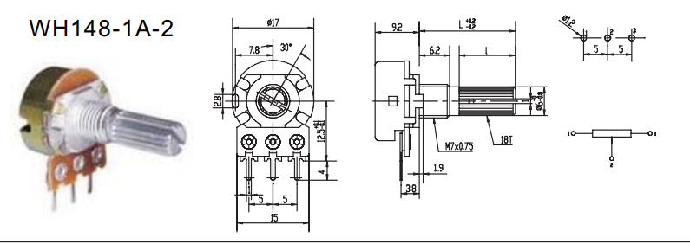

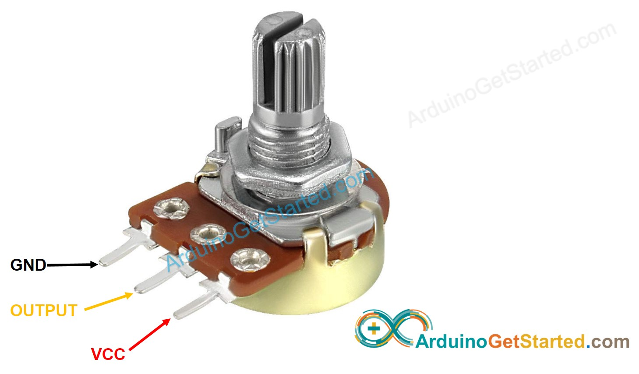

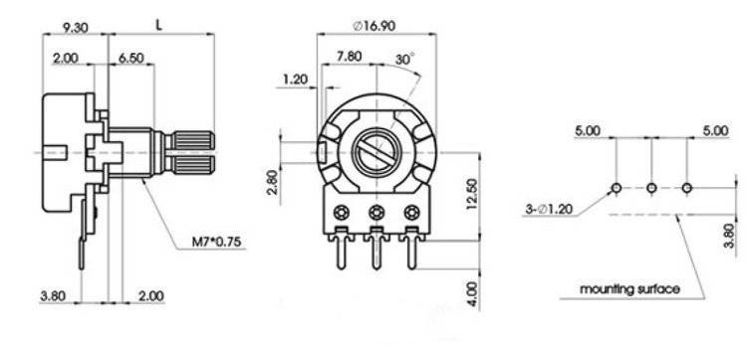

H-Bridge:

Microcontroller

### Characteristics:

Name: Motor Driver 1A Dual TB6612FBG

Dimensions: 0.8×0.8

#### Datasheet:

## Alphacool Magnetic Valve – Chrome:

Valve

### Datasheet:

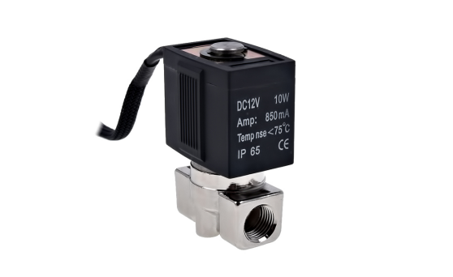

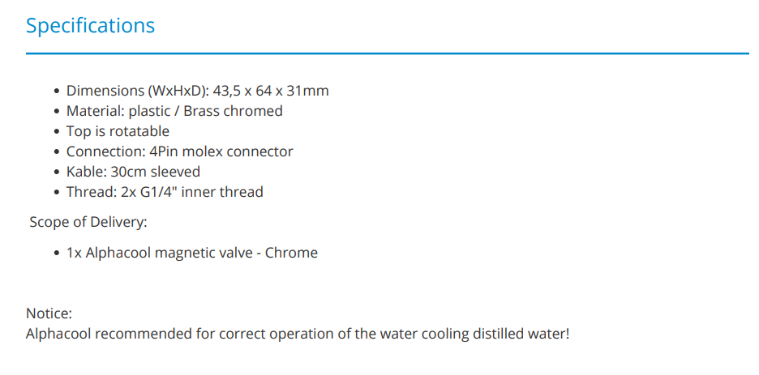

## Alphacool 17363 Eiszapfen Temperature Sensor G1/4 IG/IG Mit AG Adapter:

Temperature Sensor

### Datasheet:

### 

## Eiszyklon Aurora RGB:

Fan

### Characteristics:

1100rpm

12V

DC 1.8W

7 Pins

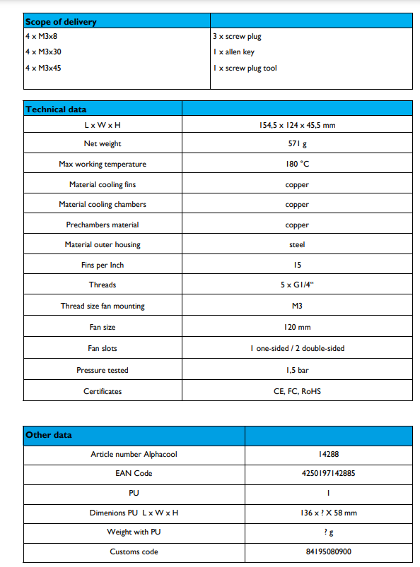

## Alphacool Hardtube:

Tube

### Characteristics:

Material: Borosilicate glass

Length: 60cm

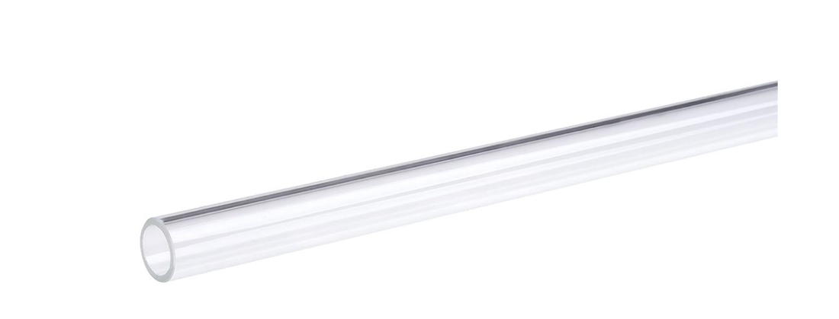

## Rasberry Pi 4:

Microcontroller

### Characteristics:

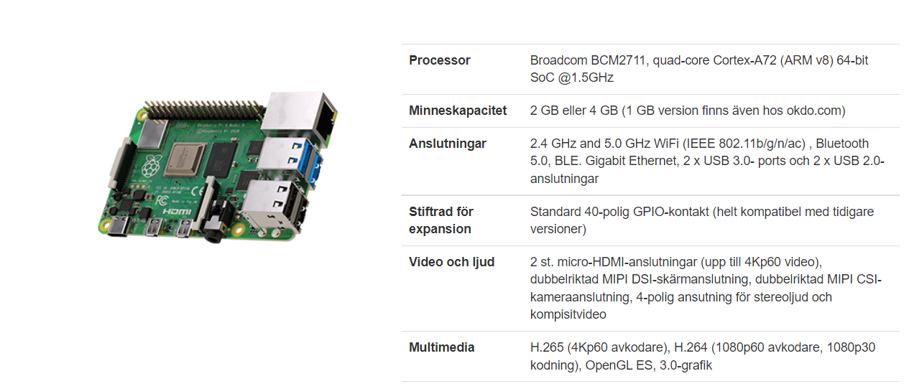

### Datasheet:

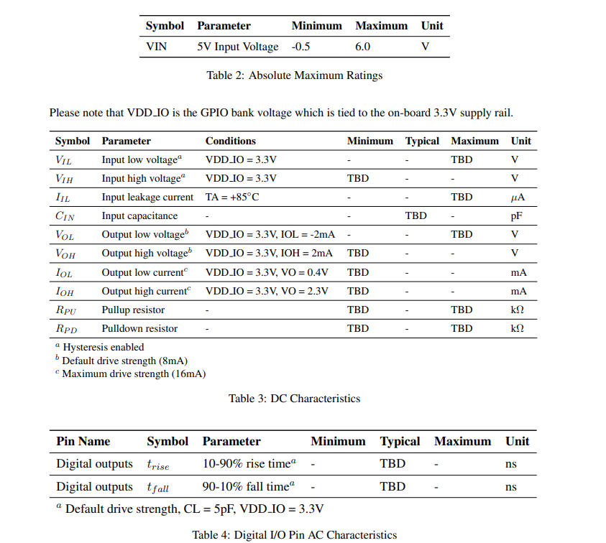

#### Pin Assignments:

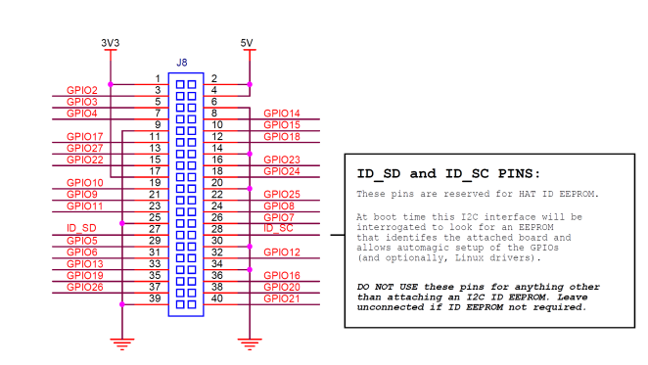

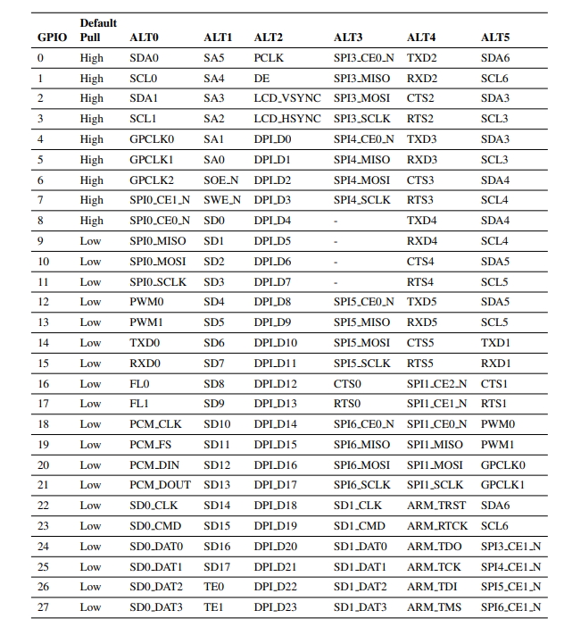

## Arduino Uno:

Microcontroller

### Datasheet:

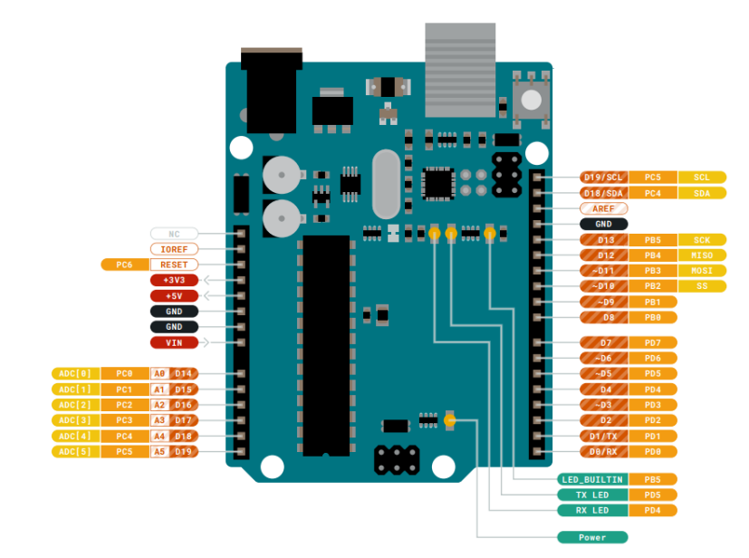

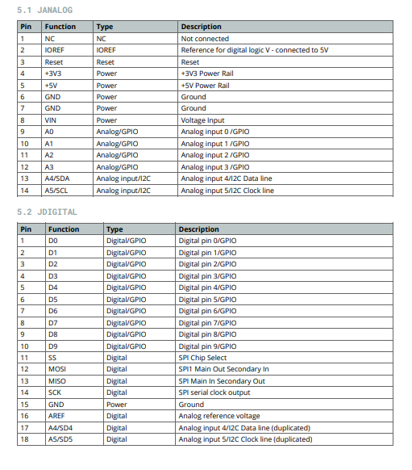

## Aqua Computer D5 Pump Motor With PWM Input And Speed Signal:

Pump

### Characteristics:

Supply voltage: 8 - 24 V DC

Power consumption: 23 W (at 12 V)  
Pressure at 12 V: 3,7 m water head

Power supply via 4 pin Molex device plug, PWM input and speed signal separately on 4 pin fan connector

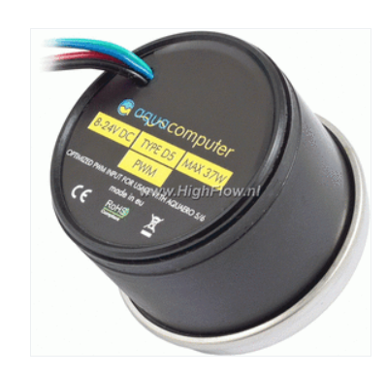

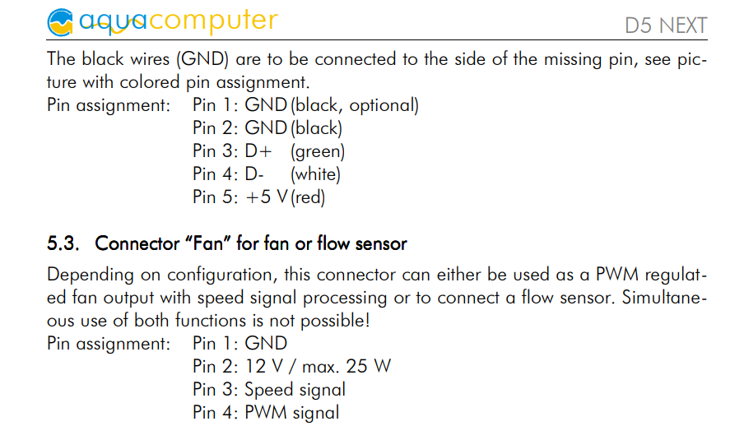

## Alphacool NexXxoS XT45 Full Copper 120mm radiator:

Radiator

### Datasheet:

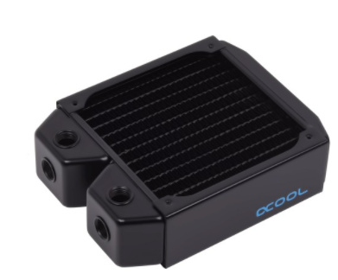



## Alphacool Icicle Temperature Sensor Plug G1/4 Chrome:

Temperature Sensor

### Characteristics:

Device type: temperature sensor

Type: Sensor

Use: for water cooling

Additional information: This is a 10kOhm temperature sensor that is compatible with the following devices: aquaero 3.07, aquaero 4.00, aquastream XT Ultra, aquaduct variants with external

Colour: chrome

YF-S201 Hall-Effect Water Flow Sensor:

Flow Sensor

### Features of Flow Sensor:

Model: YF-S201  
**Sensor Type:** Hall effect  
**Working Voltage:** 5 to 18V DC (min tested working voltage 4.5V)  
**Max current draw:** 15mA @ 5V  
**Output Type:** 5V TTL  
**Working Flow Rate:** 1 to 30 Liters/Minute  
**Working Temperature range:** -25 to +80℃  
**Working Humidity Range:** 35%-80% RH  
**Accuracy:** ±10%  
**Maximum water pressure:** 2.0 MPa  
**Output duty cycle:** 50% +-10%  
**Output rise time:** 0.04us  
**Output fall time:** 0.18us  
**Flow rate pulse characteristics:** Frequency (Hz) = 7.5 * Flow rate (L/min)  
**Pulses per Liter:** 450  
**Durability:** minimum 300,000 cycles

#### Datasheet:

##### Formula:

Here we have determined flow rate by change in velocity of water. The pipe’s cross-sectional area is known and remains constant, the average velocity is an indication of the flow rate. The basis relationship for determining the liquid’s flow rate in such cases is **Q=VxA**, where **Q** is flow rate/total flow of water through the pipe, **V** is average velocity of the flow and **A** is the cross-sectional area of the pipe (viscosity, density and the friction of the liquid in contact with the pipe also influence the flow rate of water).

* Pulse frequency (Hz) = 7.5Q, Q is flow rate in Litres/minute
* Flow Rate (Litres/Min) = (Pulse frequency) / 7.5Q

------------------------------------------------------------------------------------------

* Sensor Frequency (Hz) = 7.5 * Q (Liters/min)
* Litres = Q * time elapsed (seconds) / 60 (seconds/minute)
* Litres = (Frequency (Pulses/second) / 7.5) * time elapsed (seconds) / 60
* Litres = Pulses / 7.5

*\*Error range +-10*

*Keep in mind that i however, am not a physicist. / Robin*

*NOTE!: Theese are not the one in use anymore, switched to new ones but with same pipe area, but might be a slight difference in thickness of the impellers, which might change the equation slightly..*

###### Characteristics:

Total: 3 flow sensor

## Alphacool Eisbecher Helix 250mm Reservoir – Blue:

Fluid Reservoir

### Characteristics:

Dimensions (HxD): 250 x 65mm

Connection threads: 8x G1/4"

Helix colour / aluminium caps: blue / blue

UV cathode colour: UV

Cable length: ca. 27cm

Capacity: 340ml

## O-Ring till Laing D5/Alphacool VPP655/Swiftech MCP655

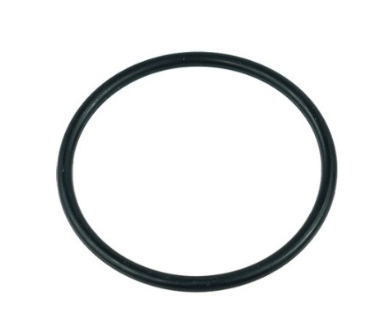

#### Characteristics:

Dimensions: 57x3.5mm

##### Information:

Change the o-ring every 5 years for the pump.

## Servo

